Due to the similar reasons that Tableau couldn’t be shown in Github and the data is a little sensitive, we put the screenshots of some of the Japan’s data analysis, visualizations here.

1. This visualizes the device type-device make of the audiences in all of the six countries that the partner company has reached. From the diagram, we could easily find the comparison of different device type, of different countries, and so on, which gives us a good understanding of the market share and furthermore a good determination base.

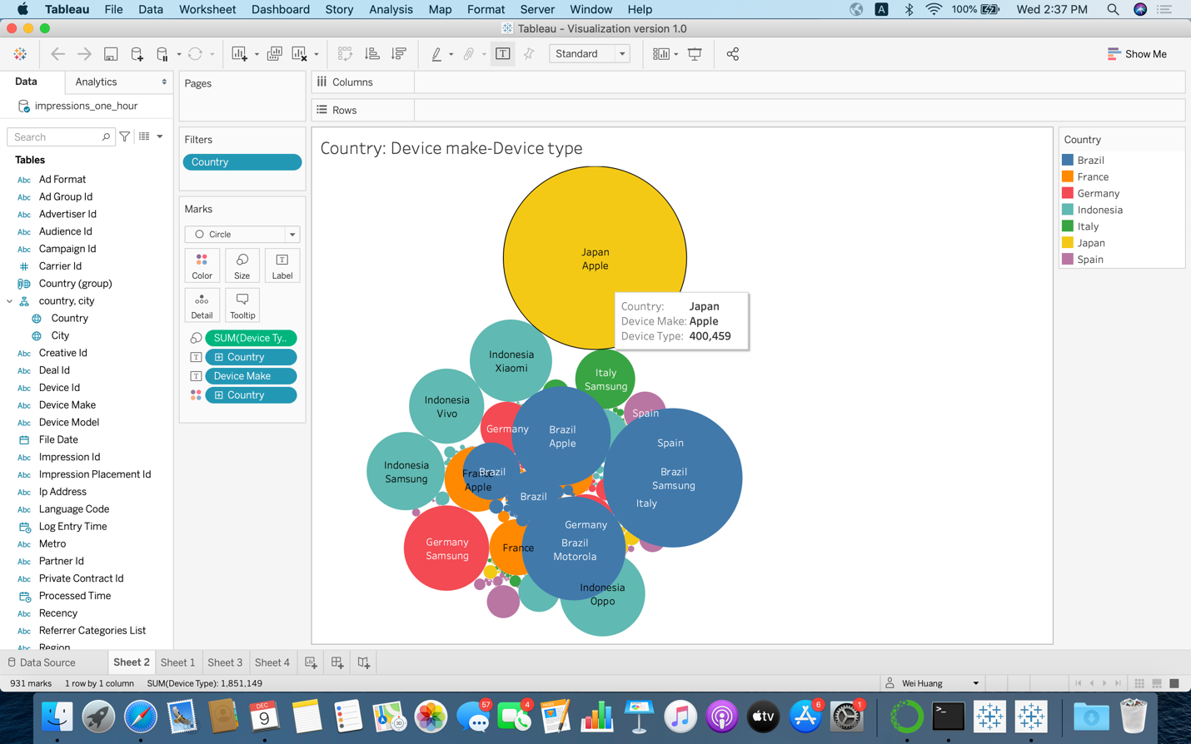

1. This figure focuses on Japan supply vendor and media cost, which shows us the cost of media for different vendors and a vivid comparison and gives us more information for the determination of cost control.

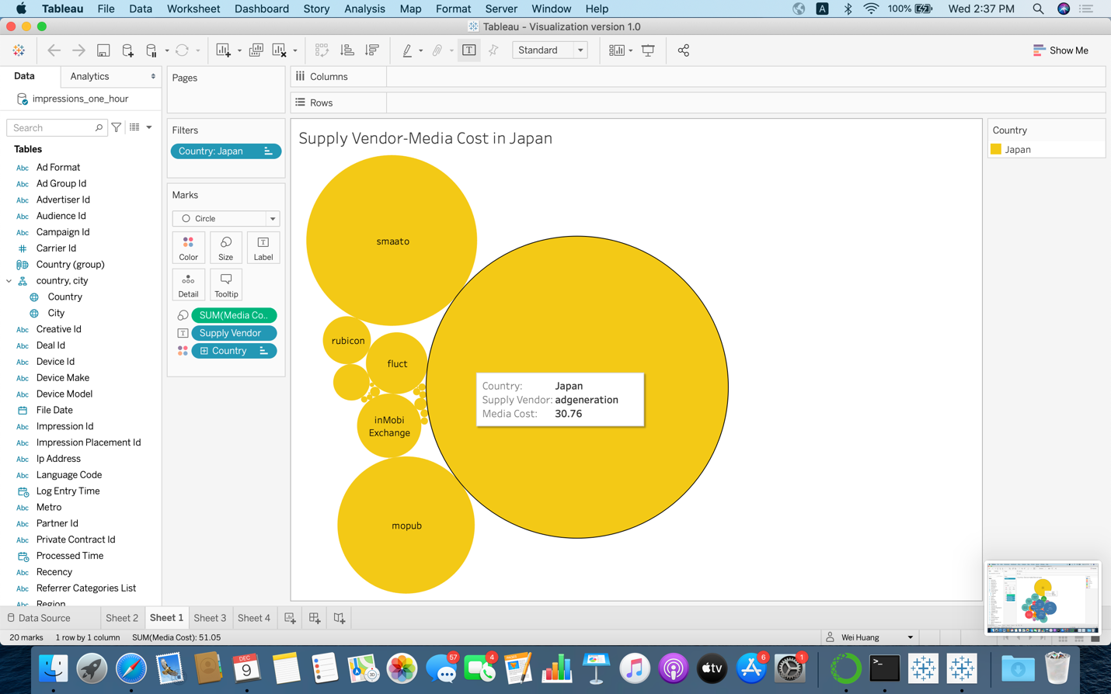

1. Another device model-device type figure specifically in Japan, giving us more information on device model.

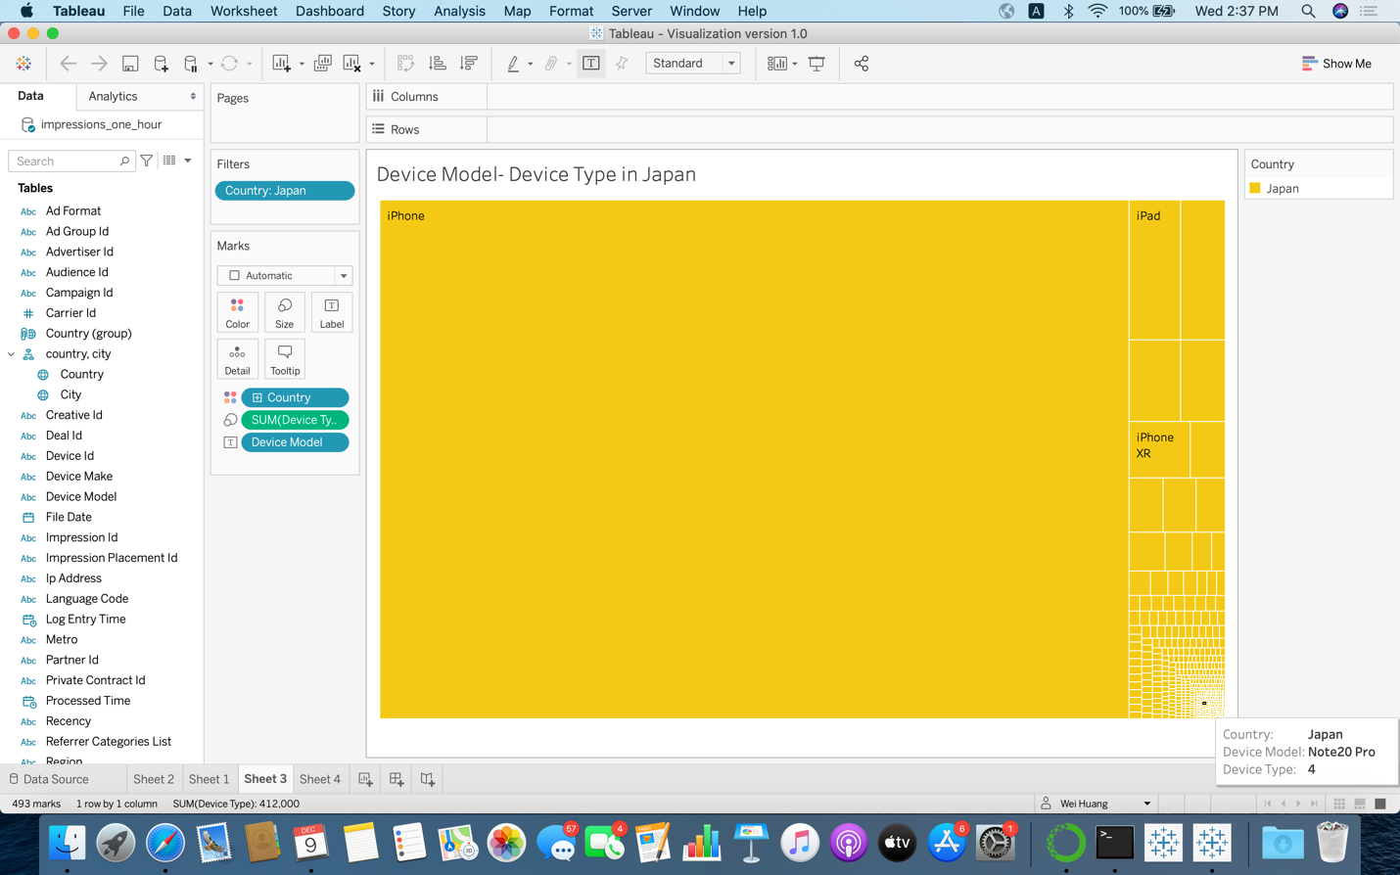

1. This diagram illustrates the city bias among different cities in Japan, despite only considering the impression data (reached audiences)

